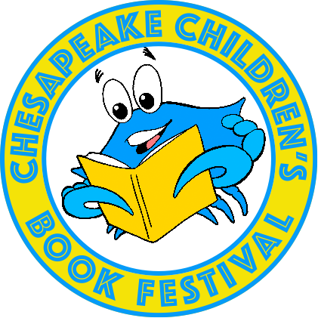

The Eighth Annual Chesapeake Children’s Book Festival
Saturday, June 24, 2023, 10am - 2pm

Author’s and Illustrator’s Registration Form

Deadline for submission: January 31, 2023

Please complete and return via email (preferred) or US Mail. Filling out and submitting this registration form means you are committing to being present at the Festival should your application be approved. For our EIGHTH year we will be selecting between 25 and 30 authors/illustrators. Those with a new book out in 2021/22 will be given preference. Audience: Pre-K thru Eighth grade children

Talbot County has a diverse population, and we hope to find authors and illustrators that represent
diverse backgrounds. Traditionally published books only, sorry, we cannot accept self-published books.

Applications must be postmarked or emailed by Tuesday, January 31, 2023. Applicants will be notified in early March. This year’s festival will be held in the Talbot County Free Library, Easton Branch.

Name:

Street Address:

City: State: ZIP:

Phone: Email:

Website:

BOOK SALES: Authors must bring and sell their own books. Please list 3 titles in the order they were published, newest first (for promotion):

Title Age Level Date Published ISBN13

1:

2:

3:

READING SCHEDULE:
Would you like to sign up for a 15 minute reading slot? This is voluntary. Due to time limits, not all authors will be able to get a time to read. YES____ NO____

We will add authors/illustrators to our website once they have been chosen and confirmed in March 2023.

Please provide the following information:

SHORT BIO: (100 words max.):

AWARDS AND HONORS your books have received:

BOOK TITLE you want publicized most:

SHORT BOOK BLURB:

LINKS: please list any links to your website, blogs or social media you want to be linked on our website:

If chosen, we will ask for a print-quality publicity photo and book cover images. (High resolution images, at least 200 DPI).

Would you consider being on a wait list for alternates should a previously chosen author not be able to attend the festival? YES____ NO____

AUTHOR/ILLUSTRATOR’S RECEPTION: On Friday night, June 23, we will be hosting an author reception for our participating authors/illustrators, plus one guest.

Continental breakfast and a lunch will be provided at the festival.

Email applications and attachments to: authors@ccbookfest.net

OR

Mail applications to:

Chesapeake Children’s Book Festival
Attn: Laura Powell
Talbot County Free Library
100 W. Dover St.
Easton, MD 21601

